LIVE & ONLINE
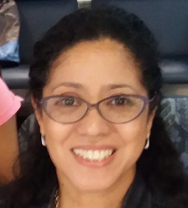
Creative Path Workshop Skills and Supervision Group
Jan Hall is Director of NeuroTribe UK, a provider of therapeutic support for Neurodiverse (SEND) children & families, she also offers attachment-based art therapy with various Adoption Agencies.
Jan provides clinical supervision and CPD Creative Coaching for facilitators and mental health professionals in the NHS, Educational and Voluntary sectors.

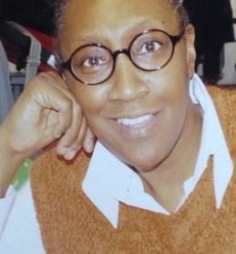
Delphine Spencer, Director of Calmwaters Therapy Service, has over 30 years’ experience in Social Services and currently as an Art Psychotherapist for a number of Adoption Agencies providing Attachment-Focused Therapy. She provides supervision for facilitators and mental health professionals in the voluntary sector and is an Academic Advisor and tutor at a leading Therapy Institute.
Special offer
£510 (£85 per session) reduced to £450 (£75 per session) when paid in full. *Details of Discounted/Funded places available upon request
A 6-month programme
NOV 2021 – APR 2022 / 15 CPD HOURS (Saturdays monthly)
Register at www.neurotribe.uk/cpd
©2018 by NeuroTribe UK CIC- A Social Enterprise

Creative Path Workshop Skills and Supervision Group
Creativity is a phenomenon whereby something new and somehow valuable is formed.- Wikipedia
Use of creative techniques to help access experiences at a sensory level can act as a bridge to the unconscious, offering new insights in our own reflective practice and in our work with clients whatever our professional approach.
“Creativity is seeing what everyone else has seen, and thinking what no one else has thought” - Albert Einstein
Increasing creativity, mindfulness, and openness to other expressions can extend the dialogue and depth of therapy. Language can be a barrier as well as a gateway to understanding. Words can be misunderstood or incomplete - images can bridge and fill gaps. Using art, movement, music, and writing can also extend the role of the client from responder to doer.
WORKSHOP 1 - CREATING SAFETY
Tasks and exercises that create and establish a sense of safety, which will enable the exploration of creativity with less fear.

WORKSHOP 2 - CREATING IDENTITY
Creative exercises and tools aimed at developing personal identity and self-definition, the drawing of new boundaries as personal needs, desires, and interests announce themselves.

WORKSHOP 3 – CREATING PERSONAL POWER
Creative interventions to explore the twin themes of anger and shame. Anger not as the action itself, but as an ‘invitation to action’ and shame experienced as a ‘controlling device’.

WORKSHOP 4 - CREATING AUTHENTICITY
This workshop considers the following statement: ‘In order to have self-expression, we must first have a self to express ‘

WORKSHOP 5 – CREATING POSSIBLITY
Creative exercises to explore what limitations keeps us stuck and how to say ‘NO’ in order to be able to say ‘YES’

WORKSHOP 6 - CREATING ABUNDANCE
Creative techniques to help examine and overcome two common major blocks – the deadly duo: Prideful Perfectionism and Creative Anorexia.

Schedule:
10.00 – 11.15 Creative Path Workshop Skills
11.15 – 11.30 Break
11.30 – 12.30 Supervision Group

Who should attend?
Psychotherapists – Counsellors – IAPT practitioners – Social Workers – Psychologists – Psychiatrists –
Therapists – Case Managers – Addiction counsellors – Other Mental Health Professionals

WHAT TO EXPECT FROM THE CREATIVE PATH WORKSHOP SKILLS AND SUPERVISION GROUP
Places on the programme are limited to provide an intimate working environment. In a small, closed group of fellow mental health professionals, from varied modalities and backgrounds, we will meet for a monthly creative-informed skills CPD workshop, followed by a group supervision session.
You will personally experience creative techniques and interventions that can prevent sessions from getting stuck, create a sense of safety, help your clients to develop self-definition, self-regulation, establish boundaries and much more! In addition to this you will receive supervision and ongoing support to boost your confidence in safely utilizing the techniques and interventions with your clients.

